Putnam Resource Allocation or Staffing Estimation Model

After successfully determining the effort needed to develop the required software product the focus should be on determining the staffing requirements or resource allocation.

Putnam studied the complete staffing problem to find out the proper solution and pattern for staffing related issues. In his study he used and extended the work of Norden who had already investigated the staffing pattern of general research and development (R&D) projects.

**Putnam’s staffing work**

Putnam while studying the problem of staffing or resource allocation for software projects learned that they have characteristics similar to any other research and development (R&D) projects studied by Norden.

Putnam stated that Rayleigh-Norden curve can be used to relate the number of delivered lines of code to the effort and the time required to develop the product. Given below is Putnam’s expression:

***L = CkK1/3***td4/3

Here,

**K**– total effort expended or manpower requirement

**L**– product size in KLOC

td – time required to develop the software.

Ck – state of technology constant and reflects constraints that impede the progress of programmer. (Typically value of Ck is **2** for **poor development environment**, **8** for **good software development environment**and **11** for **excellent development environment**)

So according to Putnam, staff build up should follow the Rayleigh curve. At the very beginning of the project only a small number of developers are needed. As the project progresses the resource allocation requirement starts increasing and reaches at its peak during the testing phase. After the implementation and unit testing is done the staff requirement again starts falling.

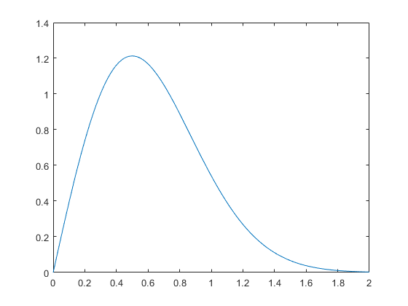

Rayleigh curve

**Calculating the software team buildup**

Average rate of software team buildup = (m0/td)

Where m0 = (K/td) * sqrt(e)

m0 = manpower or staffing required (in number of persons)

K = effort or manpower requirement in person years

td = development time

